Expense Tracker
Application

Certificate
This is to certify that the project titled “Expense Tracker Application” has been designed and implemented by the following students of C batch ,Department of Computer Engineering, College of Engineering, Chengannur, in partial fulfilment of the requirements for the course Object-Oriented Programming(PBCST304), for the Academic Year 2025–2026.
Group Members:
Name | Roll No.
Sreya Padmakumar | CHN24CS180
Anjali CS | CHN24CS042
Guided by:
Lintu Liz Thomas
Assistant Professor, Department of CSE
Sulaja Sanal
Assistant Professor, Department of CSE
Submitted to:
Lintu Liz Thomas
Assistant Professor, Department of CSE

Table of Contents

Chapter 1: Introduction
1.1 Problem Statement ............................................................................................................. 4
1.2 Objectives ........................................................................................................................... 4
1.3 Scope and Limitation .......................................................................................................... 5

Chapter 2: Problem Definition
2.1 Existing System ………………............................................................................................ 6
2.2 Proposed System ................................................................................................................6

Chapter 3: System Design & Implementation
3.1 System Overview ................................................................................................................ 7
3.2 Module Description ............................................................................................................. 7
3.3 Implementation Details ....................................................................................................... 9

Chapter 4: Result & Discussion
4.1 Screenshots with Description ............................................................................................ 10

Chapter 5: Conclusion & Future Scope
5.1 Conclusion ........................................................................................................................ 13
5.2 Future Scope .....................................................................................................................13

Expense Tracker Application Project Report

Chapter 1: Introduction

1.1 Problem Statement
To implement an Online Voting System that replaces traditional, manual voting methods with a secure, straightforward, and error-free software solution using Java.

1.2 Objectives
The main objectives of the Online Voting System are:
- To automate the voting process, including voter authentication, ballot submission, and result calculation.
- To maintain accurate and secure records of voters, candidates, and election results.
- To enable quick access and retrieval of election-related information for both voters and administrators.
- To reduce manual effort, prevent duplicate votes, and minimize errors through a digital voting system.

1.3 Scope and Limitation

Scope
- The project covers a secure, straightforward software solution for voting for small organizations, schools, and clubs.
- Voter Functionality: Registered users can log in ,view candidates ,and cast exactly one vote.
- Administrator Functionality: Admins can log in, start/stop voting , view voting results , and manage both candidates and voters.
- System Functionality: The system prevents duplicate votes , shows accurate results in real-time , and stores all information permanently in files.

Limitation
- The system uses file-based storage to manage and store voter and candidate information. It does not use a full-fledged database system (e.g., SQL).
- The target application is for a limited scale, such as schools, small organizations, and clubs.
- The system addresses the drawbacks of a manual, traditional approach but does not mention advanced security measures required for large-scale, public elections (e.g., advanced encryption, biometrics).

Chapter 2: Problem Definition

2.1 Existing System
The existing system, particularly in many schools, small organizations, and clubs, is a manual, old-fashioned voting process. This traditional approach suffers from several critical drawbacks:
- Slowness: The manual counting and verification process is time-consuming and inefficient.
- Error Prone: Human error in counting votes or tallying results leads to inaccuracies.
- Security Risks: The system is open to manipulation or fraud, as there is a risk of unauthorized changes to the ballots or results.
- Duplicate Votes: It can be difficult to reliably prevent duplicate votes from the same person.
- Lack of Real-Time Results: Results are not available immediately, requiring significant effort for compilation.

2.2 Proposed System
The proposed Online Voting System is a straightforward and secure software solution designed to overcome the drawbacks of the existing manual system.
The system offers the following key improvements and features:
- Security and Uniqueness: It ensures that registered users can vote just once and keeps their votes private, eliminating duplicate votes.
- Real-Time Accuracy: It shows accurate results in real-time for the administrator, drastically improving the speed and transparency of the process.
- Administrator Control: The admin has comprehensive tools to manage the election, including starting/stopping the voting process and maintaining the candidate and voter lists.
- Data Persistence: All crucial voter and candidate information is stored permanently in files for reliable record-keeping.

Chapter 3: System Design & Implementation

3.1 System Overview
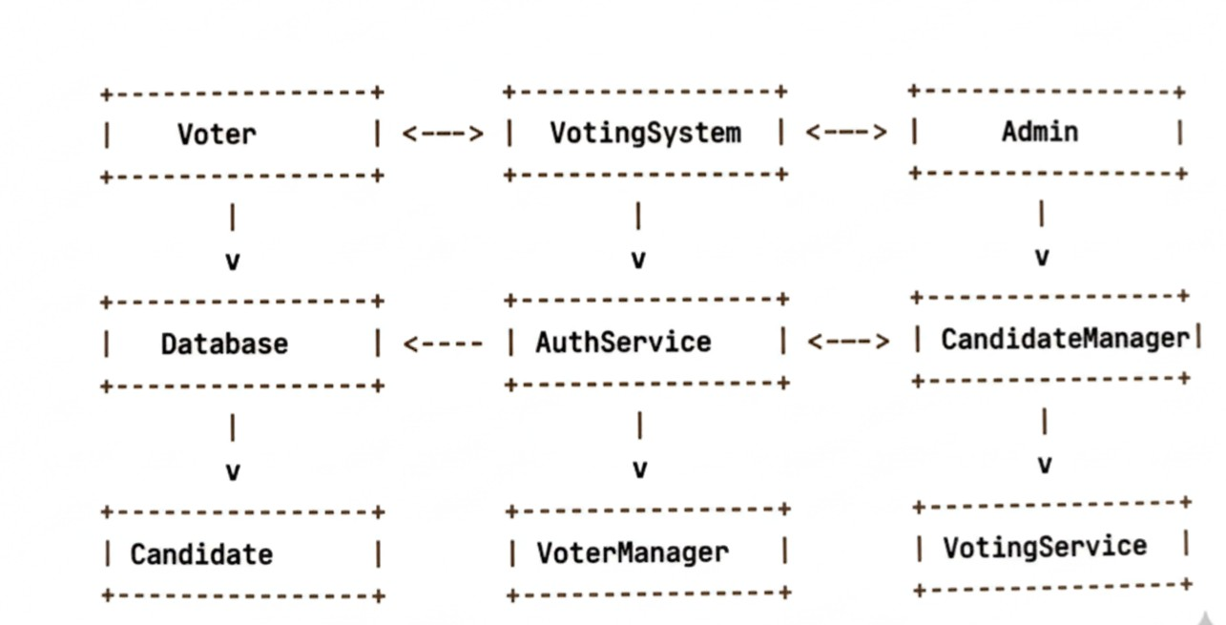

3.2 Module Description
The project utilizes several key classes (modules) built on OOP principles to manage the system's logic and data:
- Voter: Stores user details, credentials, and the essential voting status.
- Candidate: Stores the candidate's name and the crucial total votes they have received.
- DataStore: The core persistence module that handles loading and saving voter and candidate data from and to files.
- AuthService: Handles the authentication logic for both the admin and the regular voters.
- CandidateManager: Encapsulates all administrative functions for candidate management (e.g., add, edit, delete).
- VoterManager: Encapsulates all administrative functions for voter management (e.g., add, edit, delete passwords).
- VotingService: Contains the main voting logic (casting a vote) and the method for result display.
- VotingSystem: The main program controller, responsible for the menu system, starting the program, and coordinating all services and managers.
- InputHelper: A utility class for ensuring safe and validated user input.

Class Name | Attributes(Variables) | Methods(Functions) | OOP feature used
Vote r | voterId, password, hasVoted | getVoterId(), vote(), setPassword(), checkPassword(), toFileString() | Encapsulation
Candid a te | name, votes | addVote(), getVoteCount(), setName(), toFileString() | Encapsulation,  Inheritance
Data S tore | voters (Map), candidates  (List), file paths | loadData(), loadVoters(), loadCandidates(), saveData(), saveVoters(), saveCandidates() | Encapsulation, File  I/O, Association
Auth S ervice | dataStore | loginVoter(), loginAdmin() | Encapsulation,  Association
Candida t eManager | dataStore | addCandidate(), editCandidate(), deleteCandidate(), displayCandidates() | Encapsulation,  Association
V o terManage r | dataStore | addVoter(), editVoterPassword(), deleteVoter() | Encapsulation,  Association
V otingServ i ce | dataStore | castVote(), displayResults() | Encapsulation,  Association
VotingSystem | dataStore, auth, managers, services, votingOpen flag,  scanner | start(), voterLogin(), adminLogin(), adminMenu(), candidateMenu(), voterMenu() | Encapsulation
I n putHelper | (none) | readInt(), readLine(), readToken() | Utility Class,  Encapsulation

3.3 Implementation Details
- Programming Language: Java .
- IDE Used: VS Code (Visual Studio Code).
- Data Storage / Database: Data persistence relies on file-based storage. All voter and candidate information is stored and managed permanently in files. The DataStore class handles the core File I/O operations for loading and saving this data.
- Tools / Libraries: The project utilizes standard Java system libraries, including the scanner for user input and control flow in the VotingSystem , and the InputHelper utility class for safe user input.

Chapter 4: Result & Discussion 4.1 Screenshots with Description
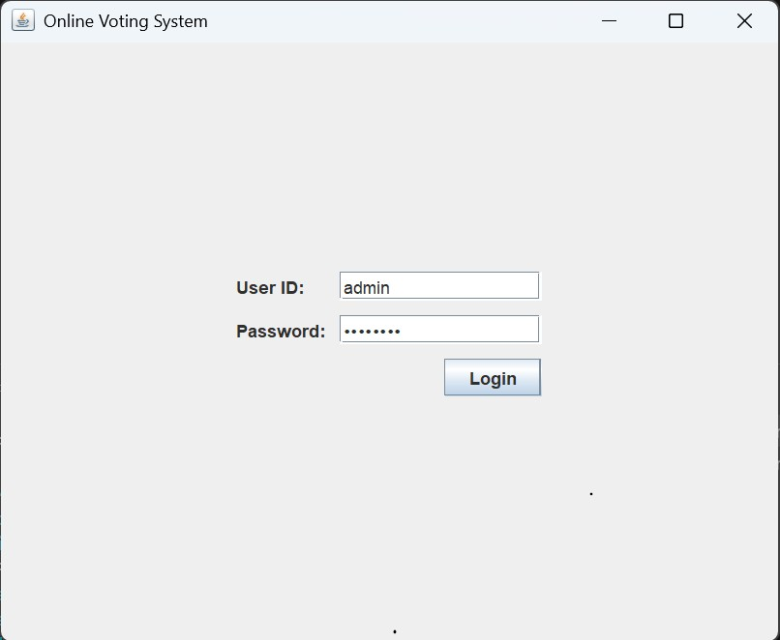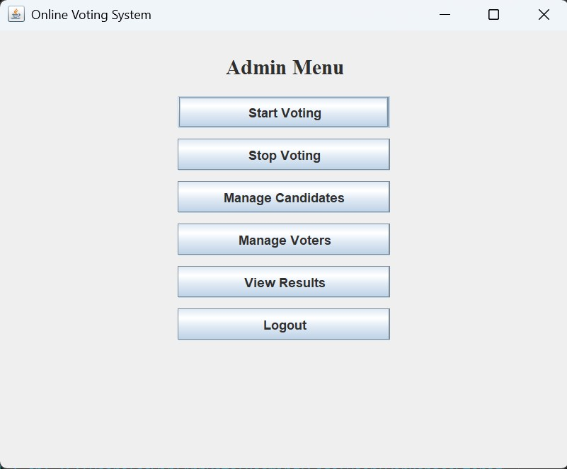
Figure 1: Admin Login Figure 2: Admin Menu
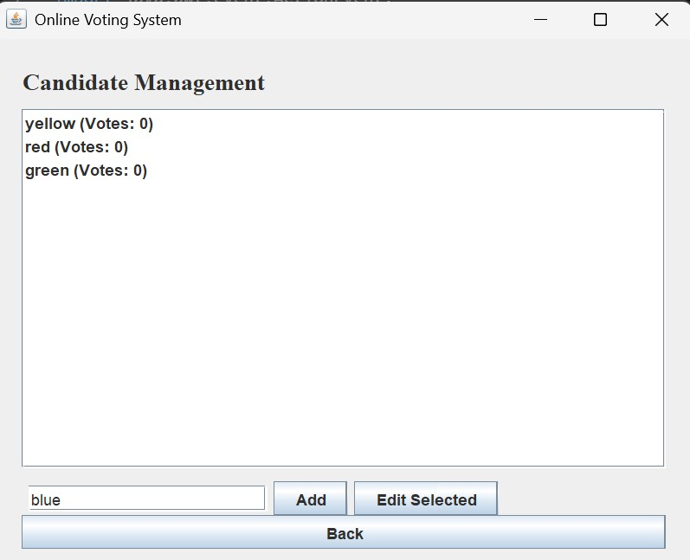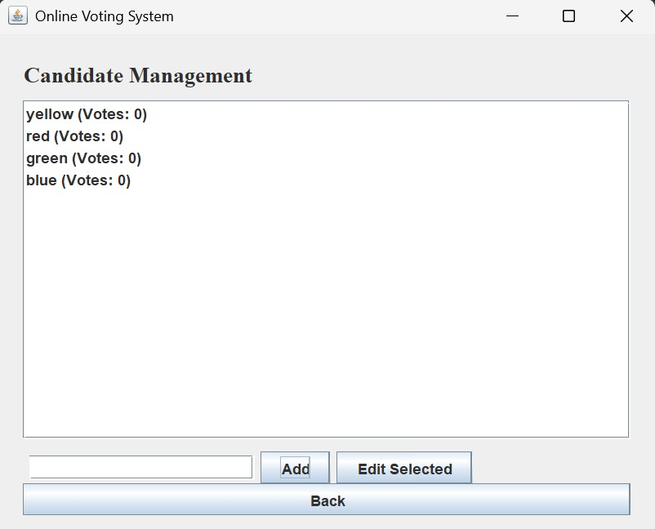
Figure 3: Candidate Before Insertion Figure 4: Candidate After Insertion
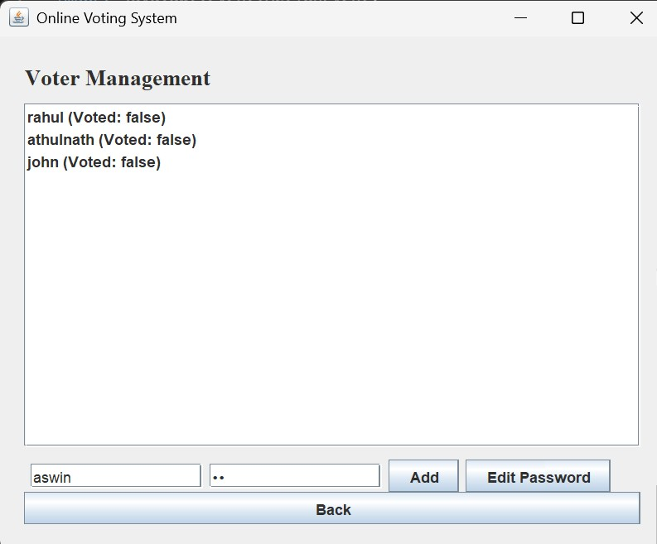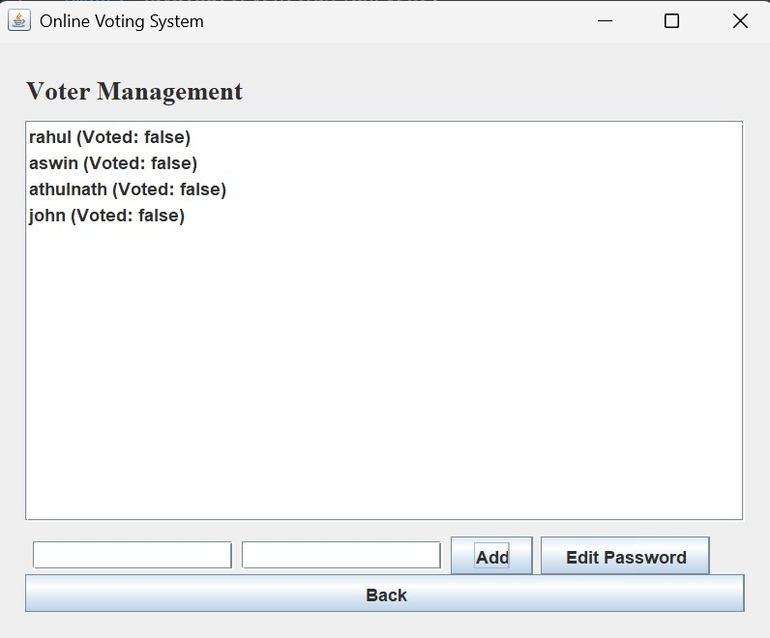
Figure 5: New Voter Added Figure 6: Voter After Insertion
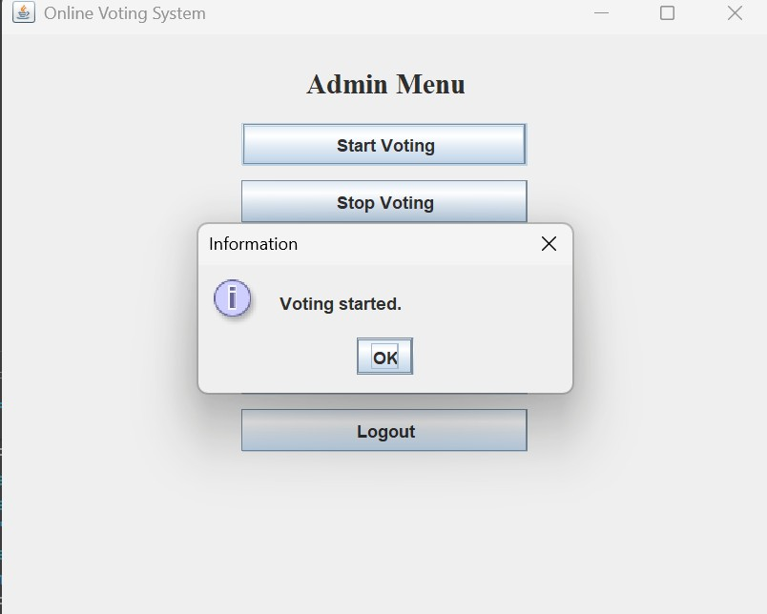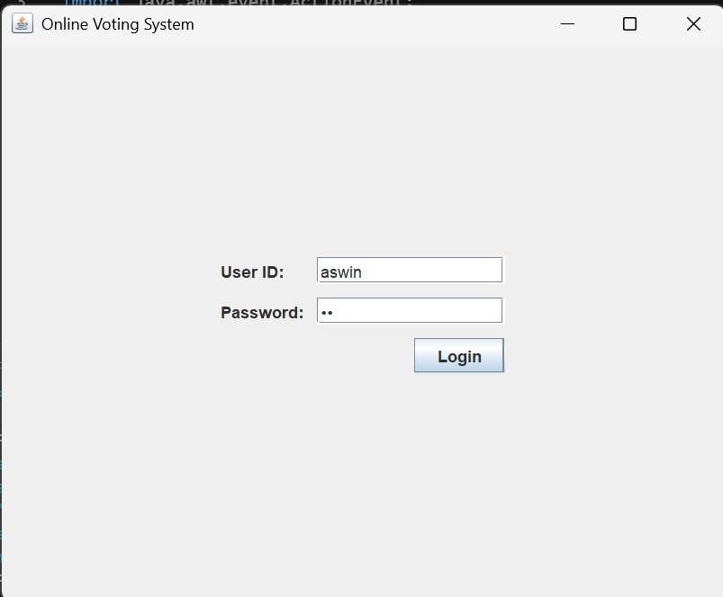
Figure 7: Voting Started Figure 8: Voter Login
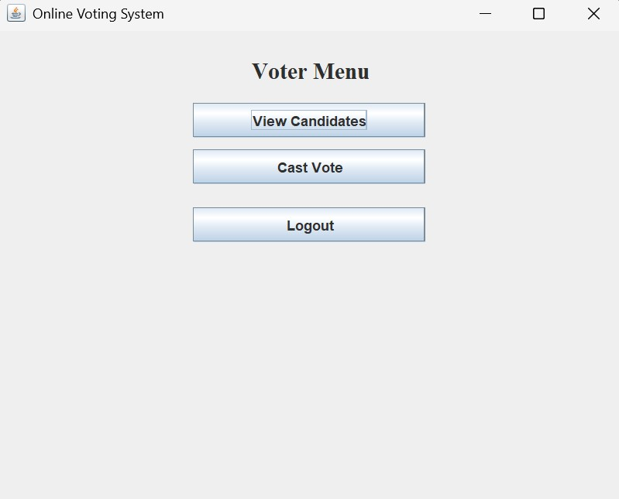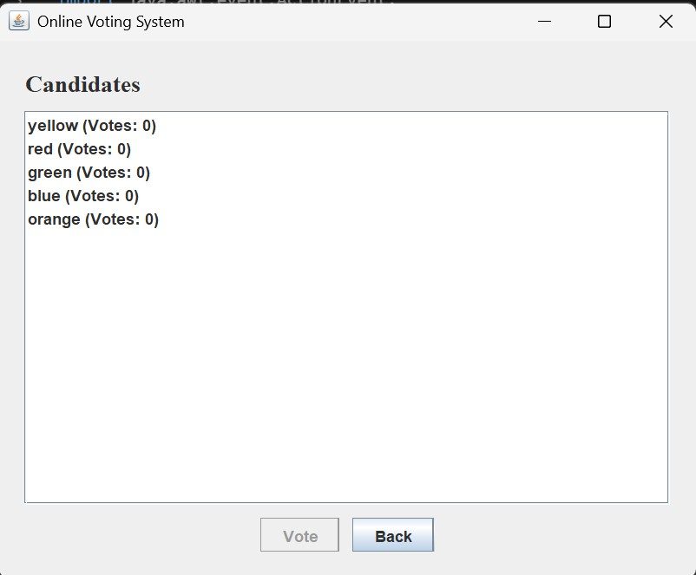
Figure 9: Voter Menu Figure 10: Candidate List
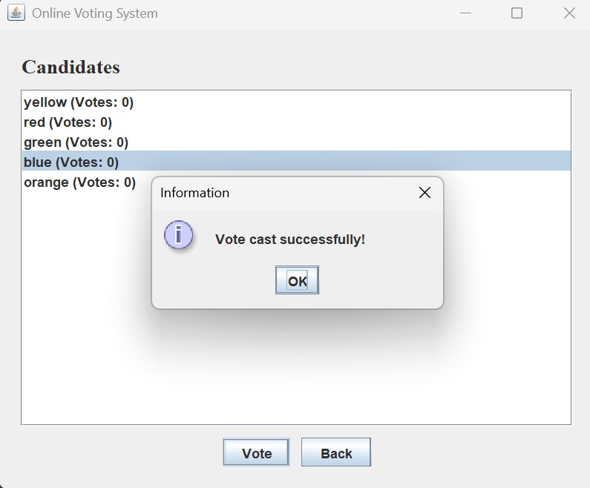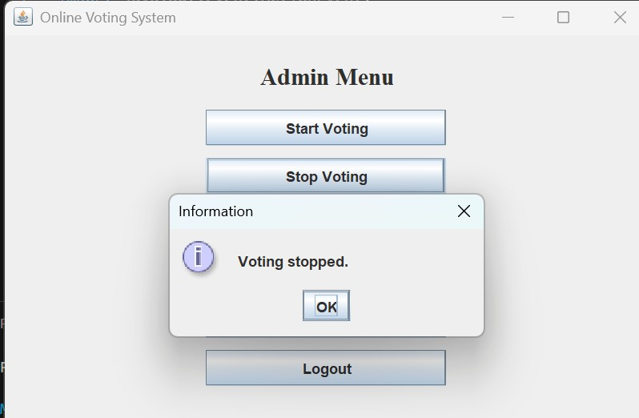
Figure12:VotingEnded
Figure 11: Vote Cast
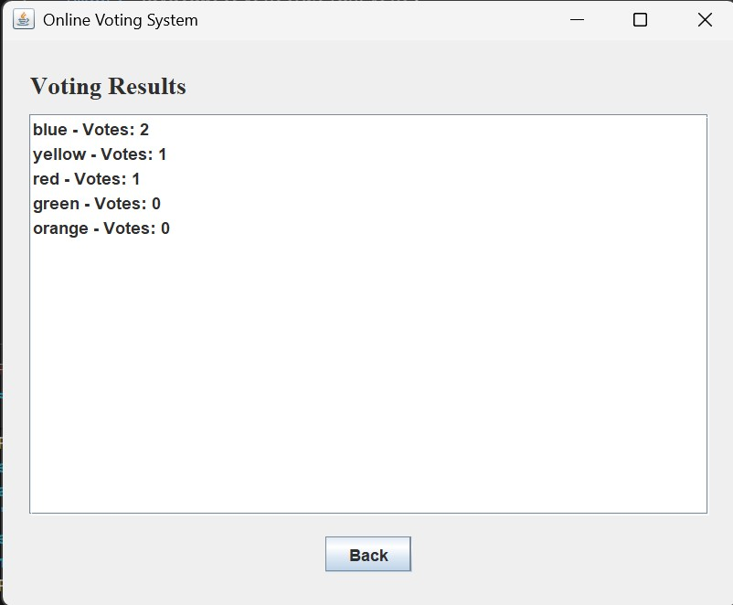
Figure 13: Result Voting

Chapter 5: Conclusion & Future Scope

5.1 Conclusion
The Online Voting System automates the voting process, making elections in small organizations more secure, efficient, and reliable. It provides a user-friendly interface for both voters and administrators, ensuring smooth operation and easy access to election-related information. By replacing manual voting with a computerized system, it minimizes errors, prevents duplicate votes, and saves time. The use of object-oriented programming concepts such as encapsulation and association improves code reusability and maintainability. Overall, the system effectively streamlines the voting process, enhances data integrity, and supports better management of election activities.

5.2 Future Scope
To enhance the system’s scalability, accessibility, and security, the following advancements are proposed:

1. Database Migration
Replace the current file-based storage with a relational database such as MySQL or PostgreSQL. This will support large-scale elections, ensure data integrity, and allow for advanced querying and analysis.

2. Web Deployment (Full Online System)
Transform the current desktop-based application into a web-based platform using Java Servlets, JSP, or the Spring Boot framework. This would enable users to vote securely from any device and location, making it a true online voting system.

3. Advanced GUI Frameworks
Upgrade the user interface from Swing to JavaFX, or adopt modern web technologies (HTML, CSS, JavaScript) to improve design aesthetics, responsiveness, and user experience.

4. Enhanced Security
Implement two-factor authentication (2FA) or biometric verification to strengthen user identity validation.

